Варіант 3

1.

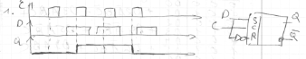

2.

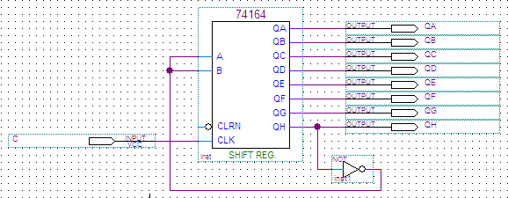

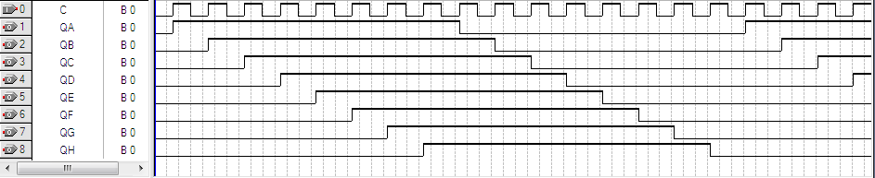

Таблиця істинності:

|  |  |  |  |  |  |  |  |  |
| --- | --- | --- | --- | --- | --- | --- | --- | --- |
| N | QH | QG | QF | QE | QD | QC | QB | QA |
| 1 | 0 | 0 | 0 | 0 | 0 | 0 | 0 | 1 |
| 2 | 0 | 0 | 0 | 0 | 0 | 0 | 1 | 1 |
| 3 | 0 | 0 | 0 | 0 | 0 | 1 | 1 | 1 |
| 4 | 0 | 0 | 0 | 0 | 1 | 1 | 1 | 1 |
| 5 | 0 | 0 | 0 | 1 | 1 | 1 | 1 | 1 |
| 6 | 0 | 0 | 1 | 1 | 1 | 1 | 1 | 1 |
| 7 | 0 | 1 | 1 | 1 | 1 | 1 | 1 | 1 |
| 8 | 1 | 1 | 1 | 1 | 1 | 1 | 1 | 1 |
| 9 | 1 | 1 | 1 | 1 | 1 | 1 | 1 | 0 |
| 10 | 1 | 1 | 1 | 1 | 1 | 1 | 0 | 0 |
| 11 | 1 | 1 | 1 | 1 | 1 | 0 | 0 | 0 |
| 12 | 1 | 1 | 1 | 1 | 0 | 0 | 0 | 0 |
| 13 | 1 | 1 | 1 | 0 | 0 | 0 | 0 | 0 |
| 14 | 1 | 1 | 0 | 0 | 0 | 0 | 0 | 0 |
| 15 | 1 | 0 | 0 | 0 | 0 | 0 | 0 | 0 |
| 16 | 0 | 0 | 0 | 0 | 0 | 0 | 0 | 0 |

Коефіцієнт перерахунку (довжина циклу) k=16.

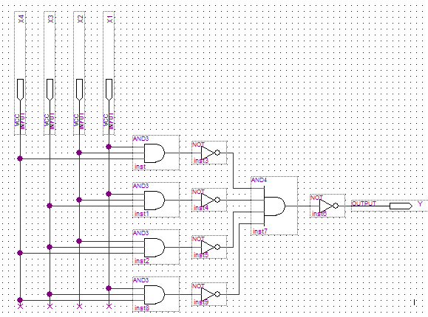3.

|  |  |  |  |  |
| --- | --- | --- | --- | --- |
| X1 | X2 | X3 | X4 | Y |
| 0 | 0 | 0 | 0 | 0 |
| 0 | 0 | 0 | 1 | 0 |
| 0 | 0 | 1 | 0 | 0 |
| 0 | 0 | 1 | 1 | 0 |
| 0 | 1 | 0 | 0 | 0 |
| 0 | 1 | 0 | 1 | 0 |
| 0 | 1 | 1 | 0 | 0 |
| 0 | 1 | 1 | 1 | 1 |
| 1 | 0 | 0 | 0 | 0 |
| 1 | 0 | 0 | 1 | 0 |
| 1 | 0 | 1 | 0 | 0 |
| 1 | 0 | 1 | 1 | 1 |
| 1 | 1 | 0 | 0 | 0 |
| 1 | 1 | 0 | 1 | 1 |
| 1 | 1 | 1 | 0 | 1 |
| 1 | 1 | 1 | 1 | 1 |

4.

